Use Case Document – CIT360

# Use Case Diagram

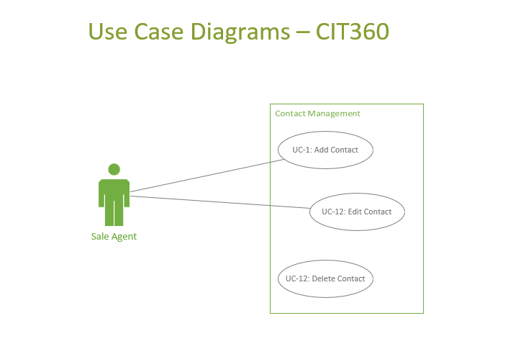

# Use Cases

* 1. Use Case 1: Add Contact

|  |  |
| --- | --- |
| Use Case ID: UC- 1 | |
| Actor | Sales Agent |
| Description | The sales agent adds a new contact to the contacts database |
| Preconditions | 1. User’s identity has been authenticated 2. User is authorized to add new contacts |
| Postconditions | A new contact is created |
| Normal Course | 1. User navigates to contacts management page 2. User has the option to create a new contact 3. User provides the first name, last name, email, phone, address, and company information 4. User saves the new contact |
| Exceptions | 1. System blocks creating a duplicated contact |

* 1. Use case 2: Edit Contact

|  |  |
| --- | --- |
| Use Case ID UC- 2 | |
| Actor | Sales Agent |
| Description | The sales agent edits an existing contact in the contacts database |
| Preconditions | 1. User’s identity has been authenticated 2. User is authorized to edit contacts 3. The contact exists in the system |
| Postconditions | An existing contact is edited |
| Normal Course | 1. User navigates to contacts management page 2. User has the option to edit an existing contact 3. User edits one or more fields: first name, last name, email, phone, address, and company 4. User saves the edited contact |
| Exceptions | System blocks creating a duplicated contact |

* 1. Use case 3: Deleting Contact

|  |  |
| --- | --- |
| Use Case ID: UC- 3 | |
| Actor | Sales Agent |
| Description | The sales agent removes an existing contact in the contacts database |
| Preconditions | 1. User’s identity has been authenticated 2. User is authorized to edit contacts 3. The contact exists in the system |
| Postconditions | An existing contact is deleted |
| Normal Course | 1. User navigates to contacts management page 2. User has the option to delete an existing contact 3. User saves the edited contact |
| Exceptions |  |